**PRACTICAL No.10**

**AIM: Write a Program to find compound interest for three years given with principal and rate of interest.**

**STEPS:**

#Write a Program to find compound interest for three years given with principal and rate of interest.

p=int(input("Enter Amount"))

r=int(input("Enter Rate of interest"))

y=3

a=(p*r*y)/100

print(a)

____________________________________________________________________________________________________________________________________________________________________________________________________________________________________________________________________________________________________________________________________________________________________________________________________________________________________________________________________________________________________________________________________________________________________________________________________________________________________________________________________________________________________________________________________________________________________________________________________________________________________________________________________________________________________________________________________________________________________________________________

**SCREENSHOT:**

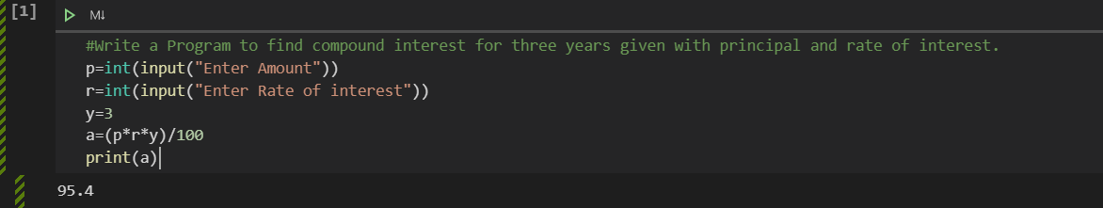

**Date:**